Software Engineering Group 11

SE.11.PP.05

Project Plan - Gantt chart

Author: Alan Spence, Theo Goree

Configuration Ref: SE.11.PP.05

Date: 2014-10-27

Version: 1.0

Status: Draft

Department of Computer Science

Aberystwyth University

Aberystwyth

Ceredigion

SY23 3DB

Copyright © Aberystwyth University 2014

Table of Contents

1. Introduction 3

2. Gantt chart 3

Term 1 3

Term 2 3

Gantt chart key 4

3. REFERENCES 5

4. DOCUMENT HISTORY 5

# Introduction

This is our Gantt chart which shows the time frame for our group tasks and deliverables through the life of the project. It is to be noted that tasks and deliverables in 2015 are educated guesses and are waiting conformation.

# Gantt chart

## Term 1

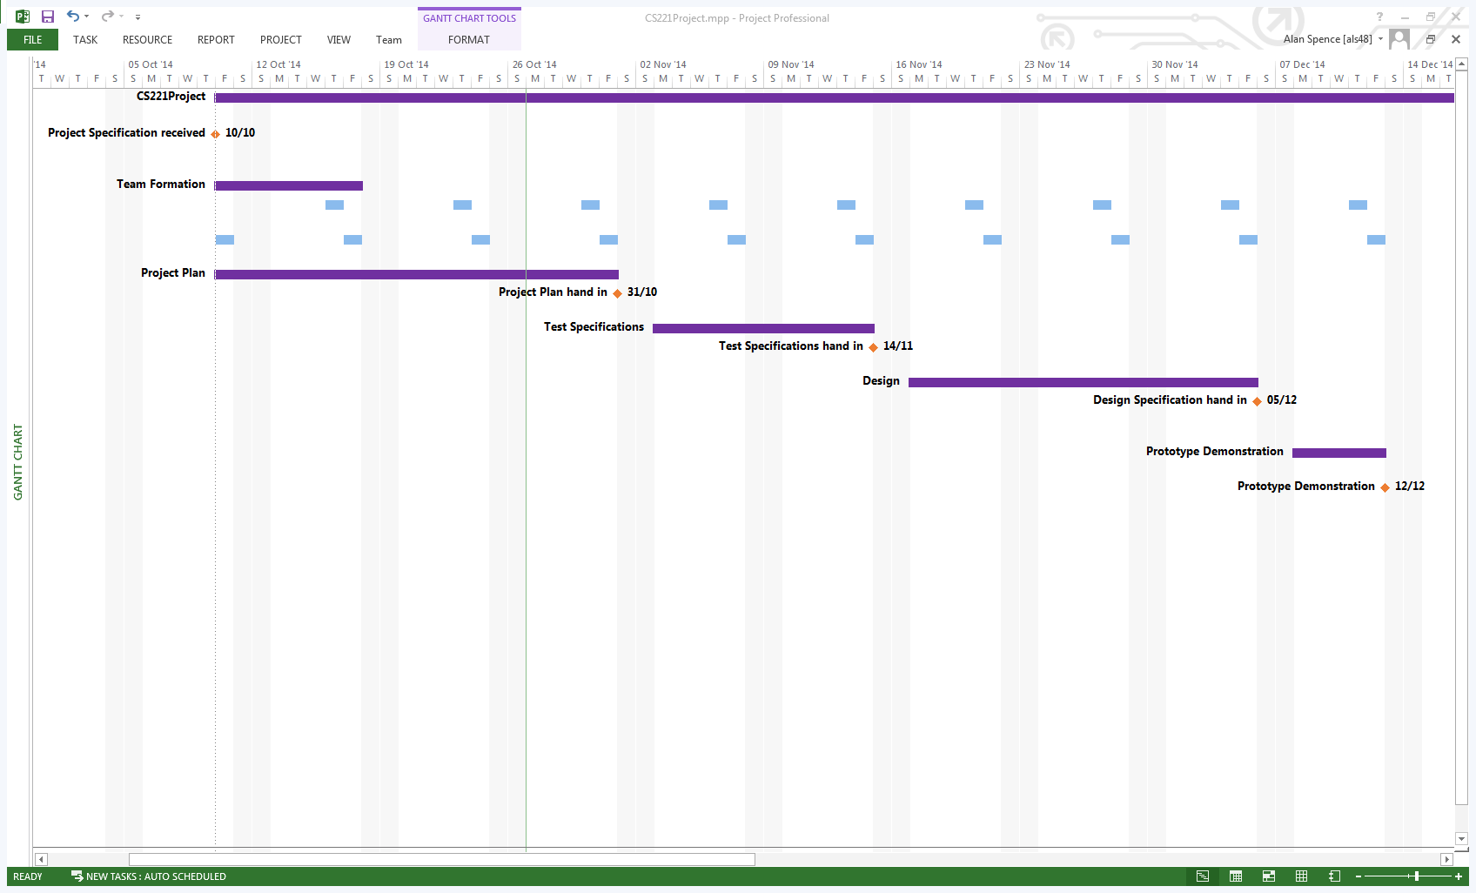

The first row of tasks repeating on Thursdays is a weekly unofficial meeting for the group.

The Second row of tasks repeating on Fridays is a weekly official meeting for the group with Project Manager Chris Loftus.

## Term 2

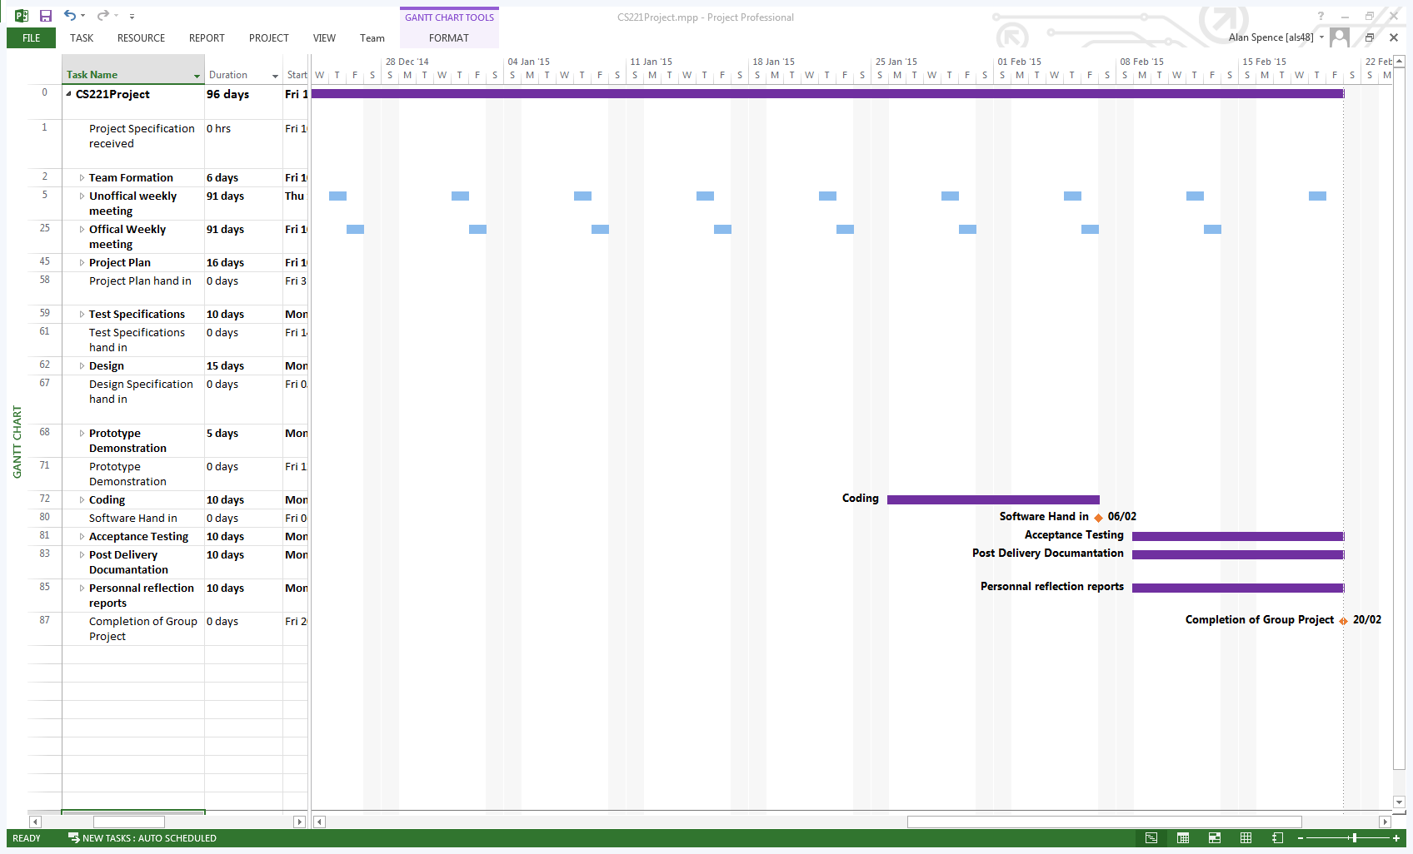

## Gantt chart key

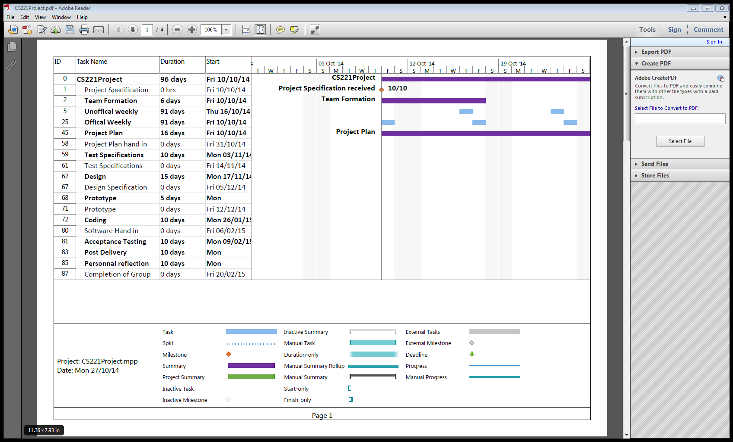

# REFERENCES

N/A

# DOCUMENT HISTORY

|  |  |  |  |  |
| --- | --- | --- | --- | --- |
| Version | CCF No. | Date | Changes made to document | Changed by |
| 1.0 | N/A | 27/10/2014 | Document Created and Structured | Als48 |